# Lab 4

In this lab we will simulate and debug code on Teva C kit that has tm4c123 SOC and arm-cortexM4 processor .

The scope is toggling a LED connected to pin3 of PORTF,

We will write Main.c , Startup.c, linker script and make file from scratch

According to specs we found out these information:

* Flash memory starts with address 0x00000000 and has size of 512M.
* Sram memory starts 0x20000000 and has size of 512M.
* SYSCTL is system control module that we will use to enable clock for PORTF has base address of 0x400FE000
* SYSCTL_RCGC2_R has offset address of 0x108 under SYSCTL we will assign this register with value of 0x00000020 to enable clock for PORTF
* GPIO module has base address of 0x40025000 and we will use three registers inside

First GPIO_PORTF_DIR_R has offset of 0x400 and we will assign value of 1 in pin3 to define this pin as an output

First GPIO_PORTF_DEN_R has offset of 0x51c and we will assign value of 1 in pin3 to enable this pin

* GPIO_PORTF_DR_R has offset of 0x400 and we will assign value of 1 in pin3 and 0 to toggle the output.

# Main.c

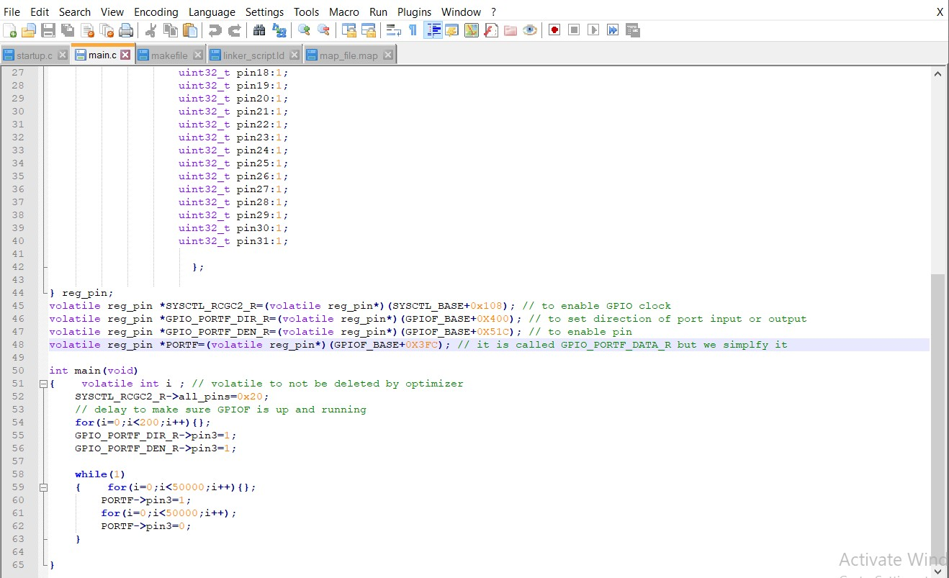

Make file :

-we will make some changes on make file : project name and we will copy a .axf file to run on kiel micro vision tool and processor name

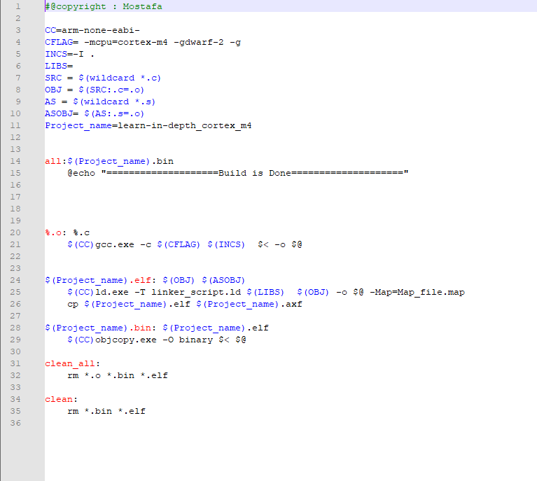

Startup.c :

In this lab we will use a new approach by initialize SP in Startup.c

Instead of create it’s symbol in Linker script our scope here to fix SP after 1024 byte of .bss section

We will use an uninitialized array of integers with 256 elements

That the total size of array will be 1024 byte and this is where SP will be at the end of the array.

Then we will make an array of pointers to functions take nothing and return void these pointers will points to each function that will handle it’s relative interrupt according to interrupt vector table .

Linker script :

We will just edit sizes and delete stack top symbol

Map file :

.bss section starts with address of 0x20000010 and ends with 0x20000410 that has been incremented by 0x400 that equivalent to 1024 in decimal

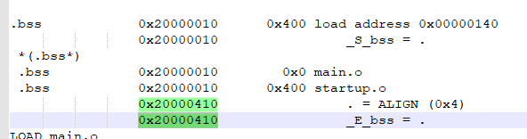

* Flash starts with 0x0000000 and the first section is .vectors section

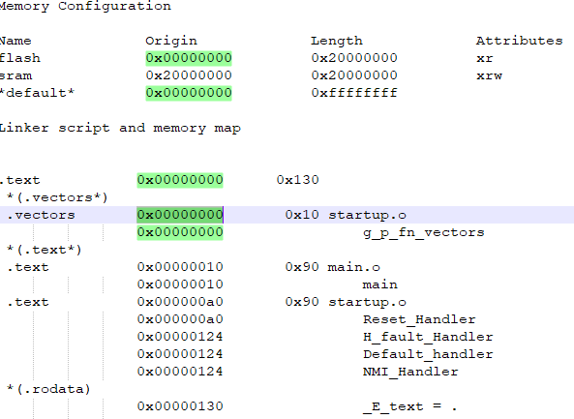

**Debugging using kiel Microvision :**

Here we show led blinking and the values of register using Texas virtual board

At low level :

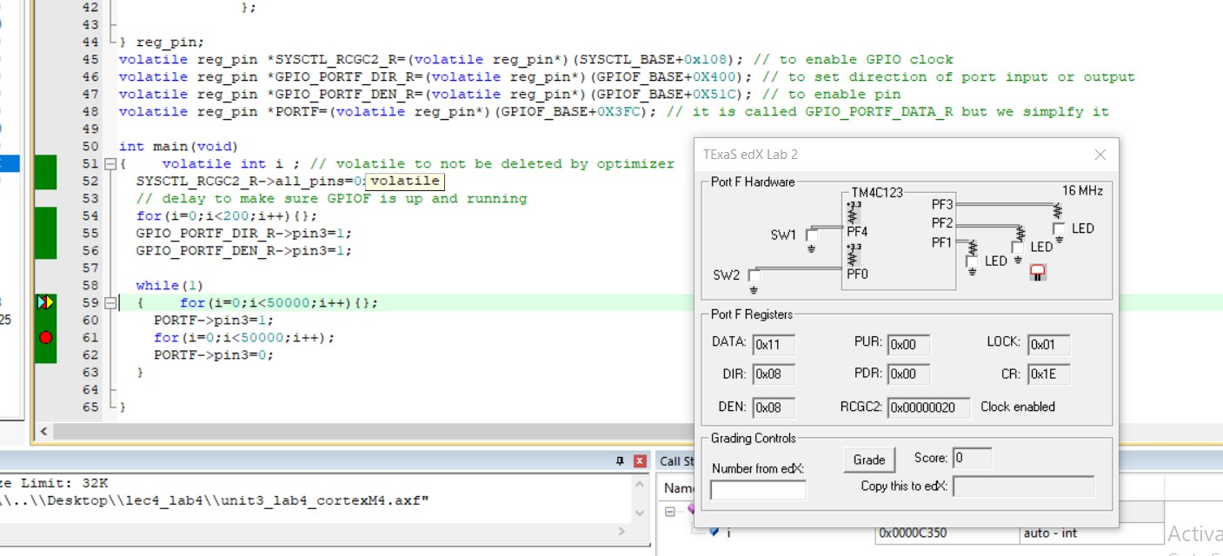

At high level :

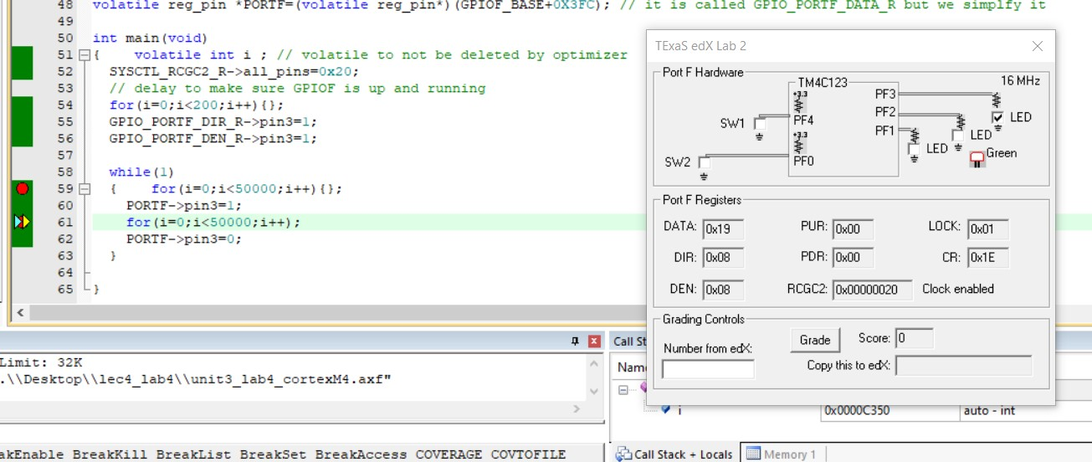

The value of PORTF data register that changes frequently :

